**Project Tasks Overview**

You will build a website for a popular music band. The fans of the band and other users will be able to perform the following actions on the site:

* See pictures from past events
* See popular lyrics of songs
* See a list of upcoming events
* Create an account
* Sign in and register for an event
* Sign in and see past registrations

**Capstone Steps**

In order to successfully complete the project, you will take the following steps:

1. Create **Get Pictures** microservice in Flask
   1. Create CRUD endpoints for picture as a resource.
   2. Create health endpoint for the microservice.
2. Create **Get Songs** microservice in Flask
   1. Set up MongoDB database.
   2. Implement the service to retrieve song lyrics from the database.
   3. Create health endpoint for the microservice.
3. Create the **Main Application** in Django
   1. Create the concert model.
   2. Use the built in Django user model.
   3. Migrate the model to create tables in the SQLite database.
   4. Implement controllers to send data to pre-defined templates.
4. Deploy the services and application
   1. Deploy **Get Pictures** to IBM Code Engine.
   2. Deploy **Get Songs and MongoDB** to Redhat OpenShift.
   3. Deploy **Main Application** to IBM Kubernetes Service.

You will be asked to take screenshots throughout the capstone to submit for peer review. You will also be asked to review your peer’s submissions.

**Capstone Architecture**

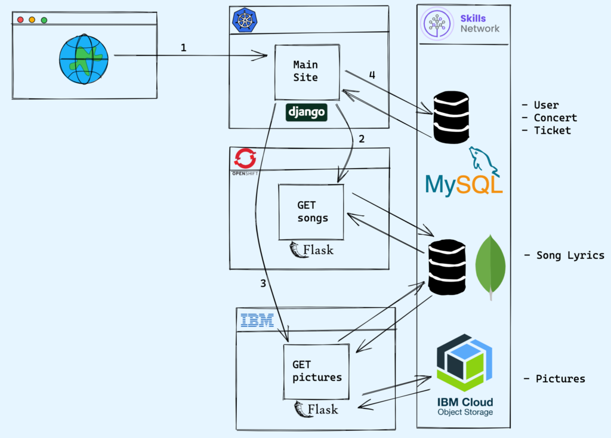

1. User visits the Django Website home page.

Anonymous use cases

2. The song page shows songs and lyrics.

3. The pictures page shows pictures from past concerts.

Admin use cases

4. Let the admin user change the concert date.

Signed in use cases

* The user signs into the application.
* The user is able to see their concerts.
* The user is able to book a concert.
* The user is able to delete their reservation.

**Review criteria**

There is a total of 40 total points possible for all graded quizzes split between the four modules of the course.

There is a total of 60 points possible for the final project.

1. Module 1: Getting Started (10 pts)
2. Module 2: Creating Get Songs Service with Flask (10 pts)
3. Module 3: Main Django Application (10 pts)
4. Module 4: Deploy your application and services (30 pts)